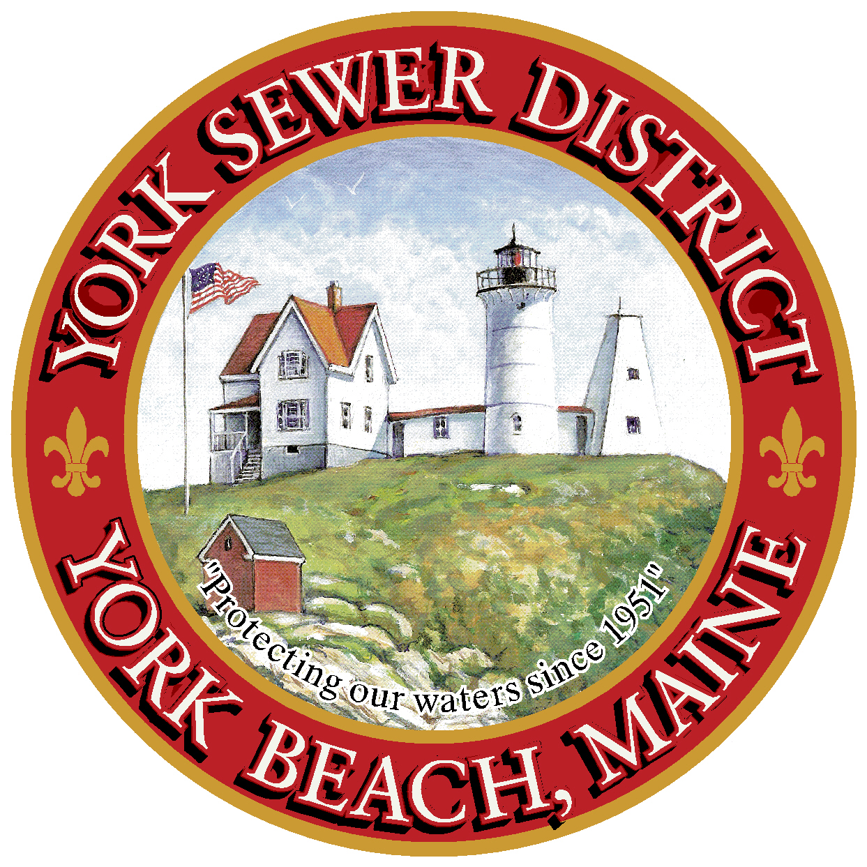

York Sewer District
Sewer Contractor Application

1. Date Application Submitted:
2. Application Fee must be submitted with this completed application. This fee is non-refundable. The fee may be paid with a check or money order.
◻ Application Fee $100.00 Received by:
3. Applicant’s Company Name:
Owner:
Business Address:

Office Contact:
Telephone Number:
Fax Number:
Email Address:
4. Please provide a narrative description of the following:
A. A brief company history indicating the Applicant has been in business for five (5) years installing and repairing sewer facilities.

B. Proof of required Insurance
Insurance Company:
Telephone Number:
Contact Person:
Name York Sewer District as also insured.
- Workmen’s Compensation, Employer’s Liability Insurance, and Occupational Disease Insurance:

- Comprehensive General Liability Insurance: in an amount of not less than $300,000.00 for bodily injury insurance and $500,000.00 for accidental death insurance for each occurrence and not less than $100,000.00 for property damage insurance

- Automobile Public Liability Insurance in an amount of not less than $300,000.00 for bodily injury insurance and $500,000 for accidental death insurance for each occurrence and not less that $100,000.00 for property damage insurance.

5. The Applicant shall provide references which shall list a minimum of five (5) sewer projects that the Applicant has performed on Sewer Systems in the last five (5) years. The intent is to permit the York Sewer District to contact parties for whom the Applicant has done Sewer System work in the immediate past. Start with your last or current project; detailing the immediate past five (5) projects. The reference is to include:
- Most Recent or Current Project
- Description of Services Provided
- Dates the work was performed
- Point of Contact
- Phone Number
- Address:

Contractors Signature:
Date:

